Raphaël Dehousse

Raphaël Dehousse
Freelance - Solution Architect

- +32 471 07 42 86
- raphael@dehousse.name
- /in/rdehouss
- Liège - Belgium

Summary
I'm a pragmatic, hands-on and tech-savvy Solution Architect (Agile) with Project Management skills for more than 15y
« You can have brilliant ideas, but if you can't get them across, your ideas won't get you anywhere »
@Lee Iaccocca

Experience

Cloud Architect & Lead, DevOps Accelerator and Change Manager
TotalEnergies Power & Gas Belgium (ex-Lampiris)
- 12/2020 - 12/2023
- Liège - Belgium
Migration to the Cloud
- Defining the technical stacks while implementing DevOps culture
- Cloud Architecture (AWS: EC2, ECS, RDS, Cognito (IAM), ...)
- Change of Operating Model (shift-left, DevOps Culture)
- Project Management

CTO / Solution Architect
Startups: Data Fellas (BDM Reco) + Esnah
- 10/2017 - 11/2020
- Liège - Belgium
AI & IoT (Big Data / Distributed)
- Created a full recommendation system with Python, Kafka, PySpark and PgSQL in a distributed architecture
- Created a complete IoT scalable and reliable architecture
- Implemented Docker Swarm cluster and migrated to it, dockerizing all apps
- Development of a Mobile App using Flutter, backends in NodeJS/Python.

Agile Coach / DevOps Coach & Agile Project Manager
The Faktory
- 08/2016 - 08/2019
- Liège - Belgium
Startup Incubator
- Helping startups to organize their team and product
- PoCs for CI/CD pipelines, demo, coaching

Solution Engineer & Agile Project Manager
Proximus
- 11/2013 - 07/2016
- Brussels - Belgium
Belgian Telco Operator - Proximus TV
- HA architecture for highly visited website (LB, Varnish, Memcached, ...)

Industry Expertise
- Leadership ★ ★ ★ ★ ⯨
- Agile / Scrum / Lean ★ ★ ★ ★ ⯨
- Project Management ★ ★ ★ ★
- SRE / DevOps / CI/CD ★ ★ ★ ★ ⯨
- Python / SQL ★ ★ ★ ★
- Jira / Confluence ★ ★ ★ ★ ⯨
- Big Data & AI ★ ★ ★ ⯨

Education
- 
- 07/2024
- 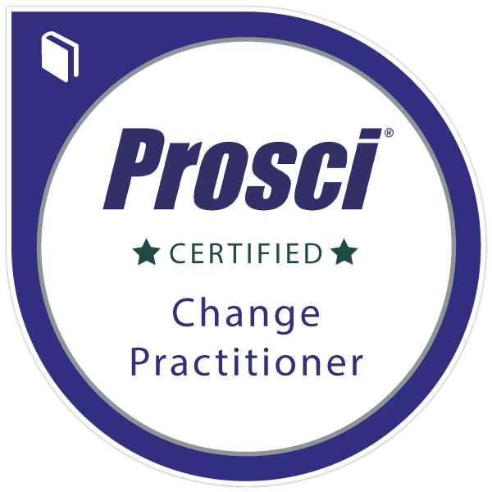
- 12/2023
- 
- 11/2021
- 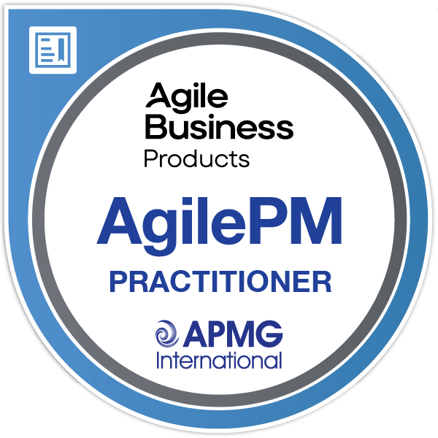
- 06/2016
- 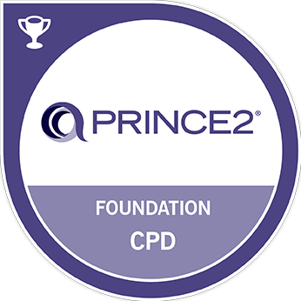
- 10/2015
- 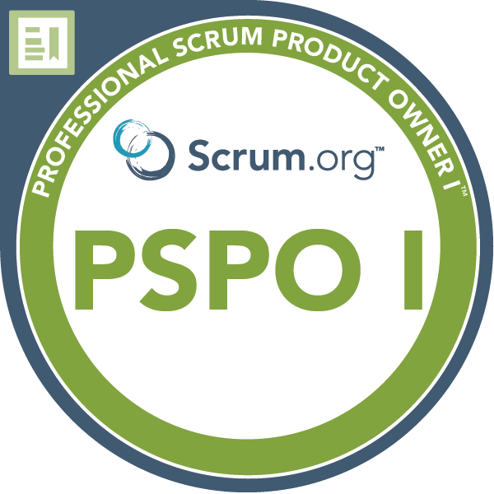
- 06/2015
- 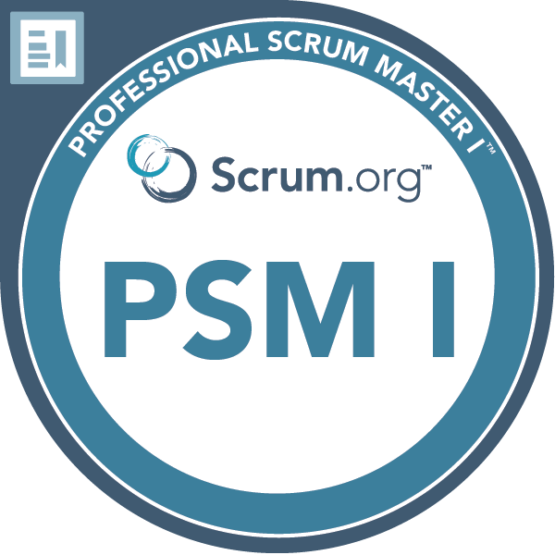
- 02/2015

Languages
- French ★ ★ ★ ★ ★
- English ★ ★ ★ ★ ⯨

Detailed relevant experience

Cloud Architect & Lead, DevOps Accelerator and Change Manager
TotalEnergies Power & Gas Belgium (ex-Lampiris)
- 12/2020 - 12/2023
- Liège - Belgium
Migration to the Cloud
- Defining the technical stacks, leading the technical maintenance, implementing DevOps culture
- Cloud (AWS) Architecture and deployment (Beanstalk, ECS, RDS, Cognito, ...)
- Change of Operating Model (shift-left, DevOps Culture)
- Project Management
Environment: Docker / NodeJS / Java / Ansible / AWS / Terraform

Agile Coach & Agile Project Manager
Startups: Data Fellas (BDM Reco) + Esnah
- 07/2017 - 11/2020
- Liège - Belgium
AI & IoT (Big Data / Distributed)
- I created the distributed architecture for the solution to be scalable, resilient and performant using Mesos/Docker Swarm for the orchestration and Kafka/Apache Pulsar for the queuing/messaging system. APIs received the IoT data and serialized them in Kafka/Apache Pulsar. Jobs consumed to data to perform different actions like quota management, statistics creation, data serialization in db, ...
- I dockerized the applications to orchestrate them via Docker Swarm instead of the previously used pm2.
- I automated the whole setup of the cluster via CI/CD (Gitlab) & Ansible: db mgmt, public keys deployment, deployment of the Traefik, Consul, Apache Pulsar, PostgreSQL, the tools around Docker Swarm, etc.
- I created bots in python and a mobile application in Flutter to work on both iOS and Android, with BLE.
- Implemented algorithms (a Cosine Similarity-like, RFV, ...) in SQL to answer <300ms with hundreds of millions of records.
- I developed ETL jobs and PySpark jobs to process the collected data (to be used by the algorithms or to generate dashboards) and also developed librairies, APIs (using aiohttp) and Jobs in python.
Environment: PySpark / Docker Swarm / Apache Pulsar / Kafka / Ansible / Metabase

Agile Coach / DevOps Coach & Agile Project Manager
The Faktory
- 08/2016 - 08/2019
- Liège - Belgium
Startup Incubator
- In order to help the startups to organize their team and product development, I created PoCs for CI/CD for demonstration purpose and promoted agile development methodologies like TDD, countinuous refactoring and collective ownership.
Tools: Jira / Confluence / Gitlab CI

Solution Engineer / Agile Project Manager
Proximus
- 11/2013 - 07/2016
- Brussels - Belgium
Belgian Telco Operator - Proximus TV
- In addition of being a PM, I remained Tech Lead/Architect for the team and helped/guided them for the technical solutions.
- I promoted TDD, pair-programming, continuous refactoring, simple design and collective ownership.
Tools: Jira / Confluence / Gitlab CI / Varnish / Memcached

