Raphaël Dehousse

Raphaël Dehousse
Freelance - IT Team Lead / Manager

- +32 471 07 42 86
- raphael@dehousse.name
- /in/rdehouss
- Liège - Belgium

Summary
I'm a driven and solution-oriented Team Lead / Manager, for Software or SRE/DevOps focusing on people & continuous improvement
« Management is the opportunity to
help people become better people »
@Clayton Christenson

Experience

Team Manager, Head of Development Teams, Change Manager
TotalEnergies Power & Gas Belgium (ex-Lampiris)
- 12/2020 - 12/2023
- Liège - Belgium
Managing up to 100 people, local & remote (nearshore/offshore)
- Promoting Operational Excellence, carry the vision of a more agile IT dpt
- In charge of making the roadmap, the capacity planning, 1-2-1s, evaluation and the recruitment of the team
- Responsible for qualitative delivery of projects and maintenance
- Change projects: Change of Operating model, Culture, Tools

CTO / IT Manager
Startups: Data Fellas (BDM Reco) + Esnah
- 10/2017 - 11/2020
- Liège - Belgium
AI & IoT (Big Data / Distributed)
- Managing a team of 7+ people both local and remote with Scrum
- Agile development (TDD, fail fast, ...) & DevOps (CI/CD, automation, ...)
- IT Architecture for IoT incl. migration to Docker Swarm cluster
- Project Management for B2B customers and partners

Agile Coach / DevOps Coach & Agile Project Manager
The Faktory
- 08/2016 - 08/2019
- Liège - Belgium
Startup Incubator
- Helping startups to organize their team and product

Solution Engineer / Agile Project Manager
Proximus
- 11/2013 - 07/2016
- Brussels - Belgium
Belgian Telco Operator - Proximus TV
- PM for Proximus TV Web/Apps + Implementing Scrumban for operations

Industry Expertise
- Leadership ★ ★ ★ ★ ⯨
- Management ★ ★ ★ ★ ⯨
- Agile / Scrum / Lean ★ ★ ★ ★ ⯨
- Project Management ★ ★ ★ ★
- SRE / DevOps / CI/CD ★ ★ ★ ★ ⯨
- Python / SQL ★ ★ ★ ★
- Jira / Confluence ★ ★ ★ ★ ⯨
- Big Data & AI ★ ★ ★ ⯨

Education
- 
- 07/2024
- 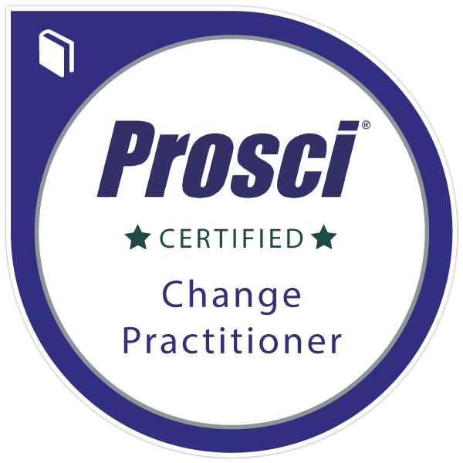
- 12/2023
- 
- 11/2021
- 
- 06/2016
- 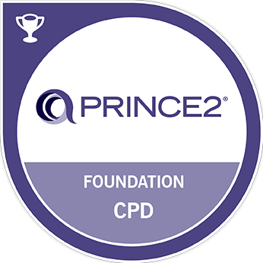
- 10/2015
- 
- 06/2015
- 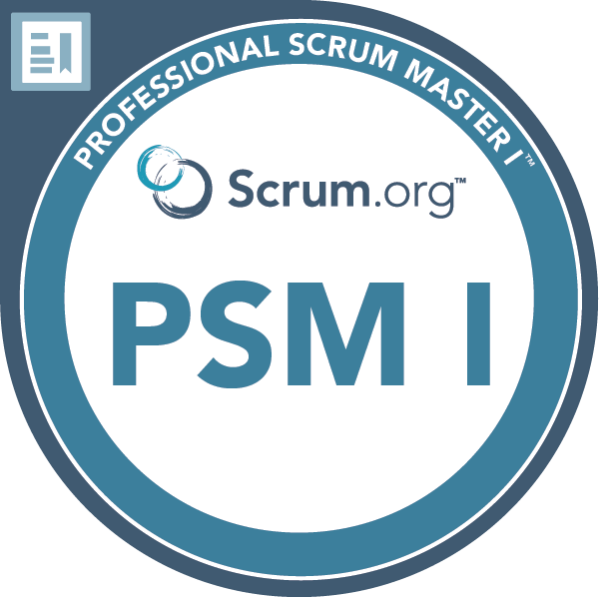
- 02/2015

Languages
- French ★ ★ ★ ★ ★
- English ★ ★ ★ ★ ⯨

Detailed relevant experience

Team Manager, Head of Development Teams
TotalEnergies Power & Gas Belgium (ex-Lampiris)
- 12/2020 - 12/2023
- Liège - Belgium
Managing up to 100 people, local & remote
- Team Management (Software team then SRE team & Head of Development, reporting to CIO)
- Transform the team from SysOps to SRE team (Change Management) and implement DevOps culture in the IT department.
- In charge of making the roadmap, the capacity planning, 1-2-1s, evaluation and the recruitment of the team
- Responsible for qualitative delivery of projects and maintenance, promoting Operational Excellence
- Collaboration with the IT & business teams to define the role of PO to improve the value delivery.
- With my Agile & DevOps experience, my goal is to coach/encourage my team to improve their practices, including their WoW and their environment, with more cooperation, better communication.
- Managing transformation projects for the whole department (i.e.: migration of 100 apps to the Cloud), including Change Management aspect (Operating model, culture)
- Merge 2 IT departments from France/Belgium, organizational & cultural changes

CTO / IT Manager
Startups: Data Fellas (BDM Reco) + Esnah
- 10/2017 - 11/2020
- Liège - Belgium
AI & IoT (Big Data / Distributed)
- Participated to strategic decisions for the company and established the technical architecture for the solution.
- Recruited and managed a team of 7+ people both local and remote. The team was composed of data scientists, data engineers, developers, a system engineer and a business dev.
- Organized the development using Scrum. I also organized regular 1-2-1 for each member of the team for their personal development.
- Responsible for the relationship with the prospects and customers (B2B), organized the demonstration and collected their inputs for our product.

Agile Coach / DevOps Coach & Agile Project Manager
The Faktory
- 08/2016 - 08/2019
- Liège - Belgium
Startup Incubator
- In order to help the startups to organize their team and product development, I organized workshops about agility and Scrum, with the role of the Product Owner and priorities management around product value

Solution Engineer / Agile Project Manager
Proximus
- 11/2013 - 07/2016
- Brussels - Belgium
Belgian Telco Operator - Proximus TV
- For the new ProximusTV Web/Apps, I managed a team of up to 12 people (web integrator, frontend/mobile and backend developers and functional analyst; onsite and offshore).
- To improve the operational team, I implemented Scrumban to have more transparency and better communication, with "backlog" management, daily standups and retrospectives

