Raphaël Dehousse

Raphaël Dehousse
Freelance - Product Owner / Agile Project Manager

- +32 471 07 42 86
- raphael@dehousse.name
- /in/rdehouss
- Liège - Belgium

Summary
I'm a pragmatic, hands-on, tech-savvy, solution-oriented Product Owner
« True Agile isn't about twice the work in half the time but about doing half the work while producing twice the value »
@Steve Denning

Experience

Team Manager, Head of Development Teams, Cloud Lead, DevOps Accelerator and Change Manager
TotalEnergies Power & Gas Belgium (ex-Lampiris)
- 12/2020 - 12/2023
- Liège - Belgium
Several positions over time, managing between 10 and 15+ people
- Creating & promoting a Vision, prioritizing the backlogs based on Value while respecting the Products

Product Owner / Agile Project Manager
Startups
- 09/2017 - 11/2020
- Liège - Belgium
AI & IOT (Big Data / Distributed)
- Understand the product and the market
- Collecting needs and feedbacks from the market
- Manage the prioritized backlog, create User Stories with Acceptance Criteria

Agile Coach / DevOps Coach & Agile Project Manager
The Faktory
- 08/2016 - 08/2019
- Liège - Belgium
Startup Incubator
- Helping startups to organize their product development using Scrum

Solution Engineer / Agile Project Manager
Proximus
- 11/2013 - 07/2016
- Brussels - Belgium
Belgian Telco Operator - Proximus TV
- Delivering new ProximusTV Web/Apps with Scrum
- Implementing Scrumban for operations

Industry Expertise
- Leadership ★ ★ ★ ★ ⯨
- Management ★ ★ ★ ★ ⯨
- Agile / Scrum / Lean ★ ★ ★ ★ ⯨
- Project Management ★ ★ ★ ★
- SRE / DevOps / CI/CD ★ ★ ★ ★ ⯨
- Python / SQL ★ ★ ★ ★
- Jira / Confluence ★ ★ ★ ★ ⯨
- Big Data & AI ★ ★ ★ ⯨

Education
- 
- 07/2024
- 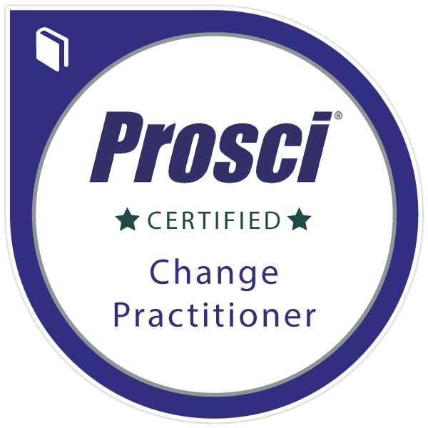
- 12/2023
- 
- 11/2021
- 
- 06/2016
- 
- 10/2015
- 
- 06/2015
- 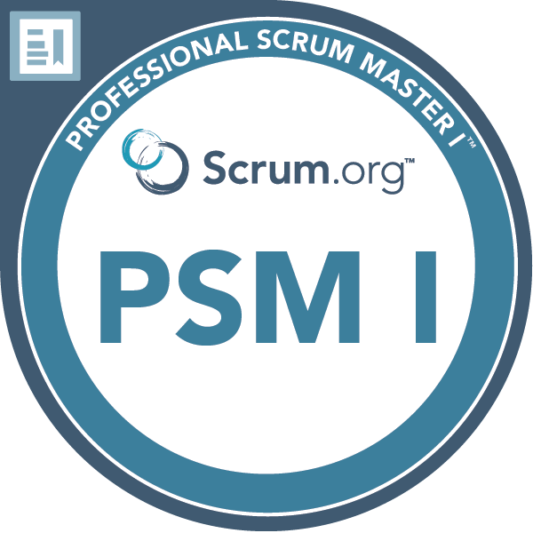
- 02/2015

Languages
- French ★ ★ ★ ★ ★
- English ★ ★ ★ ★ ⯨

Detailed relevant experience

Team Manager, Head of Development Teams, Cloud Lead, DevOps Accelerator and Change Manager
TotalEnergies Power & Gas Belgium (ex-Lampiris)
- 12/2020 - 12/2023
- Liège - Belgium
Manage teams comprising 10 to 15+ individuals, including both local and remote members
- As Head of Development, responsible for qualitative delivery of projects and maintenance with the Team Managers & PMO.
- Collaboration with the IT & business teams to define the role of PO to improve the value delivery.
- Responsible of the the Move2Cloud program (AWS) & transformation (new Operating Model) Advising on the Cloud Architecture and seeking standardization to speed up the migration.
- With my Agile & DevOps experience, my goal is to coach/encourage my team to improve their practices, including their WoW and their environment, with more cooperation, better communication.

Product Owner / Agile Project Manager
Esnah
- 09/2019 - 11/2020
- Liège - Belgium
IOT / Communication gateway for aircrafts and boats
- Collect feedbacks from prospects/customers with the help of the commercial.
Gather knowledge from the CEO (himself pilot and user of the product).
- Create the User Stories respecting the INVEST principles.
- To improve the product mgmt and the communications, I used Jira as main tool, also for the executive team. It helped the team to organize their own tasks and be more transparent and communicative about their progress.

Product Owner / Agile Project Manager
Data Fellas / BDM Reco
- 10/2017 - 09/2020
- Liège - Belgium
Big Data and AI
- I was holding the vision of the product and traveled a lot to meet the market to validate the needs and how the product should be.
- I created the User Stories respecting the INVEST principles, with Acceptance Criteria so that the stories were transparent and clear.

Agile Coach / DevOps Coach & Agile Project Manager
The Faktory
- 08/2016 - 08/2019
- Liège - Belgium
Startup Incubator
- In order to help the startups to organize their team and product development, I organized workshops about agility and Scrum, with the role of the Product Owner and priorities management around product value
- One start-up had difficulties to organize the work to deliver a connected object. I proposed them to help with using Scrum to better prioritize the backlog to deliver "user" value first before technicalities.
The start-up could finally deliver a working product to be tested by their market to collect feedbacks in much less time.

Solution Engineer / Agile Project Manager
Proximus
- 11/2013 - 07/2016
- Brussels - Belgium
Belgian Telco Operator - Proximus TV
- For the new ProximusTV Web/Apps, I managed a team of up to 12 people (web integrator, frontend/mobile and backend developers and functional analyst; onsite and offshore).
- To improve the operational team, I implemented Scrumban to have more transparency and better communication, with "backlog" mgmt, daily standups and restrospectives

