Raphaël Dehousse

Raphaël Dehousse
Freelance - Scrum Master / Agile Coach

- +32 471 07 42 86
- raphael@dehousse.name
- /in/rdehouss
- Liège - Belgium

Summary
I'm a pragmatic, hands-on and solution-oriented Scrum Master, passionate by Agile and servant-leadership for more than 10y
« True Agile isn't about twice the work in half the time but about doing half the work while producing twice the value »
@Steve Denning

Relevant experience

Agile Project Manager
NRB
- 10/2024 - Present
- Liège - Belgium
Project for ORES
- Manage project in Water-Scrum-fall mode.

DevOps Architect
Croix-Rouge de Belgique
- 04/2024 - Present
- Namur - Belgium
Mentoring and CI/CD
- Development mentoring, best practices, docker, automation
- CI/CD on Azure DevOps

Scrum Master, Agile Coach and Project/Change Manager
TotalEnergies Power & Gas Belgium (ex-Lampiris)
- 12/2020 - 12/2023
- Liège - Belgium
Agile transformation
- Implemented Product oriented Squads with Guilds & SRE/DevOps
- Added the role of Product Owner in the organization + coaching
- Development with Scrum, Ops with Kanban/Scrumban
- Teams of up to 15 people, onsite and nearshore/offshore.
- Tools: GitHub, Gitlab, Azure DevOps, Jira/Confluence

Agile Coach, Scrum Master & Agile Project Manager
The Faktory + Startups
- 08/2016 - 11/2020
- Liège - Belgium
AI & IoT (Big Data / Distributed)
- Re-organize the exec. and dev teams to be more agile (coaching)
- Managing teams of 7+ people both local and remote with Scrum/Kanban
- Agile development (TDD, fail fast, ...) & DevOps (CI/CD, automation, ...)
- Coaching startups to transform their product development to Agile
- Project Management for B2B customers and partners

Industry Expertise
- Leadership ★ ★ ★ ★ ⯨
- Agile / Scrum / Lean ★ ★ ★ ★ ⯨
- Project Management ★ ★ ★ ★
- SRE / DevOps / CI/CD ★ ★ ★ ★ ⯨
- Python / SQL ★ ★ ★ ★
- Jira / Confluence ★ ★ ★ ★ ⯨
- Big Data & AI ★ ★ ★ ⯨

Education
- 
- 07/2024
- 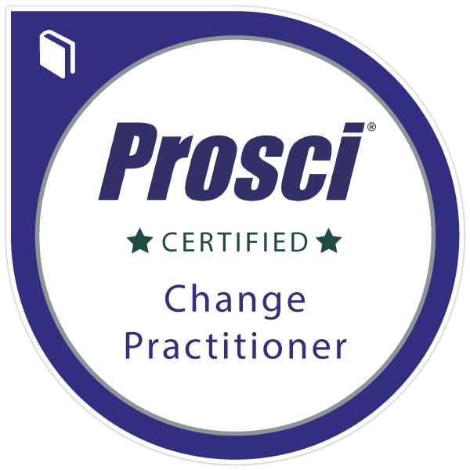
- 12/2023
- 
- 11/2021
- 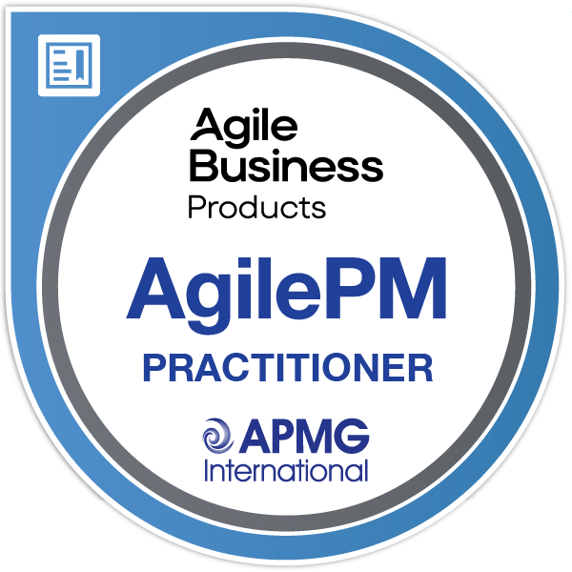
- 06/2016
- 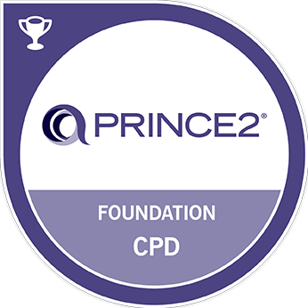
- 10/2015
- 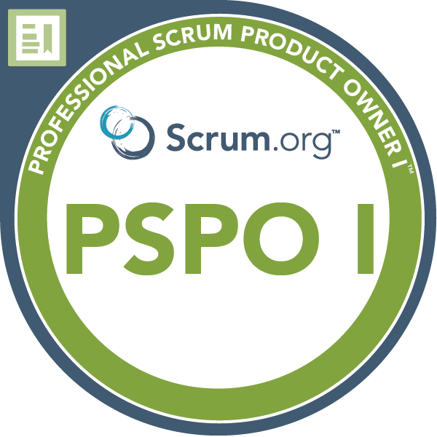
- 06/2015
- 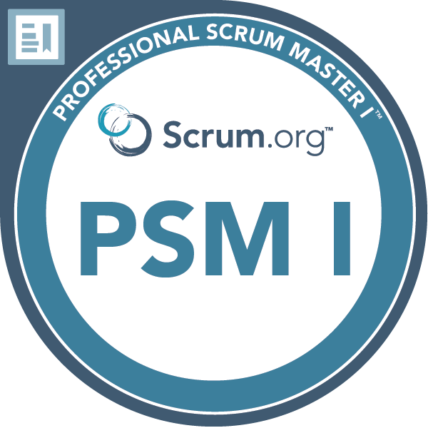
- 02/2015

Languages
- French ★ ★ ★ ★ ★
- English ★ ★ ★ ★ ⯨

Detailed relevant experience

Agile Project Manager
NRB
- 10/2024 - Present
- Liège - Belgium
Project for ORES
- Manage project in Water-Scrum-fall, work with business owner to deliver the highest value to meet stakeholders expectations

DevOps Architect
Croix-Rouge de Belgique
- 04/2024 - Present
- Namur - Belgium
Mentoring and CI/CD
- Development mentoring, best practices, docker, automation
- Refactor, improve and complete CI/CD Azure Pipelines on Azure DevOps for .NET Core (backend) and Angular (frontend)

Scrum Master, Agile Coach and Project/Change Manager
TotalEnergies Power & Gas Belgium (ex-Lampiris)
- 12/2020 - 12/2023
- Liège - Belgium
Agile transformation
- Implemented a product-oriented organization (à la Spotify), re-organizing the teams (onsite & nearshore/offshore) into Squads with the DevOps culture with a new SRE team in charge of pushing automation and CI/CD in the IT department.
- Collaboration with the IT & business teams to define the role of PO to improve the value delivery.
- Responsible of the the Move2Cloud program (AWS) & transformation (new Operating Model, more DevOps/SRE) Advising on the Cloud Architecture and seeking standardization to speed up the migration.
- Unification of both country's (FR/BE) department, reorganizations, reporting to CIO
- With my Agile & DevOps experience, I coached/encouraged the teams to improve their practices, including their WoW and their environment, with more cooperation, better communication.

Agile Coach & Agile Project Manager
Startups: Data Fellas (BDM Reco) + Esnah
- 07/2017 - 11/2020
- Liège - Belgium
AI & IoT (Big Data / Distributed)
- With my agile experience, my primary goal was to make the executive and development team agile. I managed the development teams and organized the development using Scrum and the DevOps culture (CI/CD, automation, ...)
- The retrospectives helped the teams to identify slowing factors like the lack of open communication or fear of asking help.
- To improve the product mgmt and the communications, I used Jira as main tool, also for the executive team. It helped the teams to organize their own tasks and to be more transparent and communicative about their progress.
- I had local and remote cross-functional teams composed of Data Scientists, Data Engineers, GIS Engineer, Developers and SysAdmins.

Agile Coach / DevOps Coach & Agile Project Manager
The Faktory
- 08/2016 - 08/2019
- Liège - Belgium
Startup Incubator
- In order to help the startups to organize their team and product development, I organized workshops about agility and Scrum, with the role of the Product Owner and priorities management around product value.
- One start-up had difficulties to organize the work to deliver a connected object. I proposed them to help with using Scrum to better prioritize the backlog to deliver "user" value first before technicalities.
The start-up could finally deliver a working product to be tested by their market to collect feedbacks in much less time.

